Name: ___________________________________ Class: __________

Directions:
- Find one recipe (your choice) from a magazine, newspaper, or recipe book. The recipe must contain at least two whole numbers, two mixed numbers, and two fractions.
- Copy or cut out the complete recipe, including the ingredients and the directions.
- Create a table to display your ingredients.
Ex.
Ingredient | Amount in Recipe  ___Servings | Amount in Recipe  ___Servings | Amount in Recipe  ___Servings

- Double the ingredients in your recipe. Re-write or type the recipe with the doubled ingredients.
  - To double a recipe, add the amounts together. For example: if the original recipe called for 1 1⁄2 cups sugar, you would double it by adding 1 1⁄2 + 1 1⁄2 = 3 cups sugar
  - Remember to double the number of servings (if this amount is stated on the original recipe).
  - Please note: you do not need to double the baking/cooking time, just the ingredients & serving size.
- Half the ingredients in your recipe. Re-write or type the recipe with the halved ingredients.
  - To half a recipe, divide the amounts by 2. For example: if the original recipe called for 1 1⁄2 cups sugar, you would divide it by 2 Ex. 1 $\frac{1}{2}$ $÷2$ = $\frac{3}{4}$ cups sugar
  - Remember to half the number of servings (if this amount is stated on the original recipe).

- Multiply the ingredients in your recipe by 30 to feed the amount of students in your class. Re-write or type the recipe with the ingredients.
- Include a page of looseleaf where you organize and neatly show your calculations.
- Glue the original recipe to a piece of construction paper.
- Cut out or draw pictures of the ingredients and of the finished recipe and glue on construction paper.
- Please make sure that it looks nice. Take pride in your work.
Example of Final Copy Layout on Construction Paper
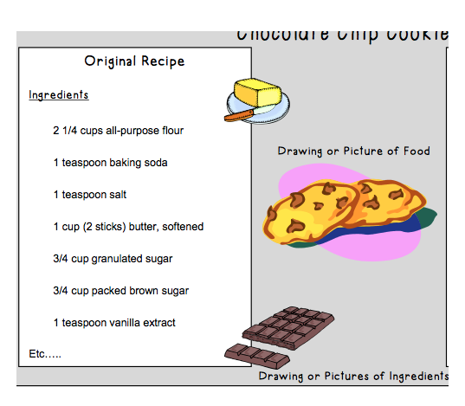
CHOCOLATE CHIP COOKIES

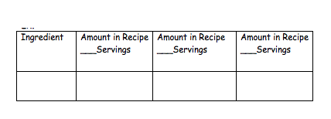

Name: ________________________________ Class: _________ Total Points: ______
GET COOKIN’
REQUIREMENTS | FEEDBACK
PART A: Basic Calculations  - Steps to double, halve, and maximize recipe using given values are correctly displayed  - Number sentences are clearly written  - Calculations are accurate  - No errors are evident when solving each part of problem | POINTS: _____/10
PART B: Proper Solutions  - Ingredient amounts are listed in simplest form  - Ingredients are labeled with proper measurement units | POINTS: _____/5
PART C: Multiple Strategies  - Use a variety of methods to multiply and divide with fractions and mixed numbers to demonstrate knowledge and skills needed to solve the problem  - Explain method using math vocabulary | POINTS: _____/5
PART D: Creativity and Organization  - Work is visually appealing  - Information is organized and neat | POINTS: _____/5

