Name______________________ Class _____
Sipping Starbucks
Ms. Soto loves Starbucks coffee. Today, while waiting to place her order for her double mocha latte, she noticed the prices for the three sizes that were available.
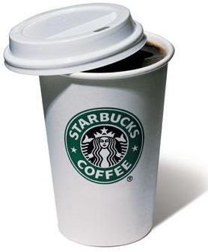
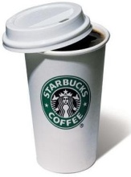
She could order:
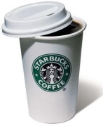

Tall Grande Venti
12 oz 16 oz 20 oz
$3.55 $4.25 $4.55

Part A
Which cup is the best buy? ____________________________
Show your work:

Part B
Ms. Soto would like to purchase the best deal for a few of her coworkers. She decides to order a jug of coffee which can hold 1 gallon. How much will this cost?

Part C
Explain how you arrived at your solution.
_____________________________________________________________________________
_____________________________________________________________________________
_____________________________________________________________________________
_____________________________________________________________________________
_____________________________________________________________________________
_____________________________________________________________________________
_____________________________________________________________________________
_____________________________________________________________________________
_____________________________________________________________________________
_____________________________________________________________________________

Name______________________ Class _____
Bingeing on Breyers
Ms. Rabinowitz loves ice cream. Today, while at the grocery store, she noticed the prices for three different available sizes.
She could purchase:

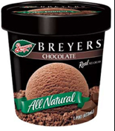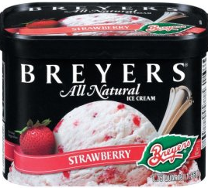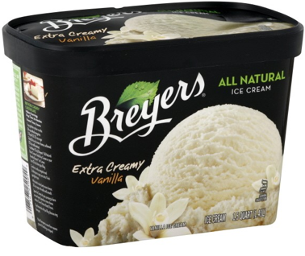

1 pint 1 quart 1 gallon
$4.89 $6.99 $8.36

Part A
Which container is the best buy? ____________________________
Show your work:

Part B
Ms. Rabinowitz would like to purchase the best deal for an ice cream social for her students. If each serving is ½ cup, how many containers will she need to buy in order to share ice cream with her 65 students?

Part C
The students were given a variety of toppings for their ice cream sundaes. Use the table below to calculate the amount of each topping that was eaten by the students.
Topping | Size | Amount Consumed
Rainbow Sprinkles | 2 ¼ quarts | 0.735
Hot Fudge | 0.83 pints | 42%
Chocolate Chips | 7.05 cups | 3/8

Part D
Explain how you arrived at your solution.
_____________________________________________________________________________
_____________________________________________________________________________
_____________________________________________________________________________
_____________________________________________________________________________
_____________________________________________________________________________
_____________________________________________________________________________
_____________________________________________________________________________
_____________________________________________________________________________
_____________________________________________________________________________
_____________________________________________________________________________

Name______________________ Class _____
Snacking on Sandwiches
Ms .J.Smith loves sandwiches. Today, while at Subway, she noticed the prices for three different available sizes.
She could purchase:

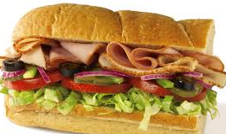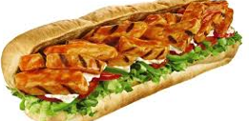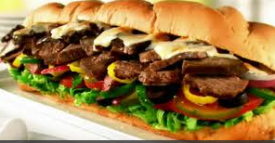

8 inch sub 1 foot sub 15 inch sub
$7.99 $10.53 $14.28

Part A
Which sandwich is the best buy? ____________________________
Show your work:

Part B
Ms. J.Smith can also choose 3 add-ins for her sandwich. Her choices are listed below:

Add-in | Serving | Cost
Lettuce | 4 oz. | $0.39
Tomato | 2.5 oz. | $0.24
Onions | 3 oz. | $0.28
Peppers | 2 oz. | $0.21
Pickles | 3.5 oz. | $0.33

If Subway offers a discount of 15% off each add-in less than $0.25 and 25% off each add-in more than $0.25, which add-ins should she choose?

Part C
Explain how you arrived at your solution.
_____________________________________________________________________________
_____________________________________________________________________________
_____________________________________________________________________________
_____________________________________________________________________________
_____________________________________________________________________________
_____________________________________________________________________________
_____________________________________________________________________________

_____________________________________________________________________________
_____________________________________________________________________________
_____________________________________________________________________________

