Name: _________________________________________________________________ Class: ________________
Directions: Use substitution to simplify each expression. Circle your final result.
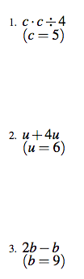
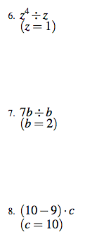

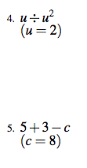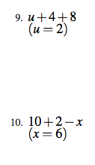

Name: _________________________________________________________________ Class: ________________
Directions: Use substitution to simplify each expression. Circle your final result.
