Name: _______________________________________________________________ Class: __________________
Use the Distributive Property to display the area for each rectangle by writing two equivalent expressions (one factored form , one expanded form). Use order of operations to simplify each expression and check your result is correct

1. 2.
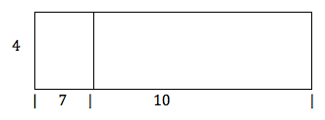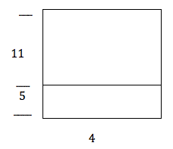
1. FACTORED FORM | 1. EXPANDED FORM | 2. FACTORED FORM | 2. EXPANDED FORM

3. 4.
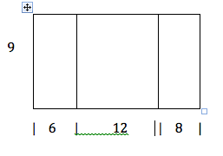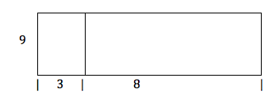
3. FACTORED FORM | 3. EXPANDED FORM | 4. FACTORED FORM | 4. EXPANDED FORM
5. 6.
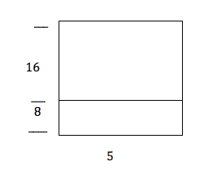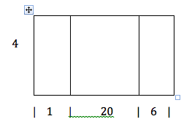

5. FACTORED FORM | 5. EXPANDED FORM | 6. FACTORED FORM | 6. EXPANDED FORM

For each expression below:
- draw and label a rectangle to represent
- rewrite in other form (factored/expanded)
- simplify and circle result

7. 6 ( 8 + 9 ) 8. 12 ( 4 + 11)

