Name: _______________________________________________________ Class: ____________

Terry wants to make 3/5 of a batch of chocolate chip cookies. Rewrite her recipe so that she only needs 3/5 as much of each ingredient.

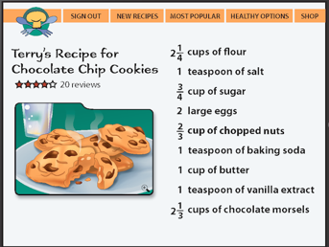

_____________ flour
_____________ salt
_____________ sugar
_____________ eggs
_____________ chopped nuts
_____________ baked soda
_____________ butter
_____________ vanilla extract
_____________ chocolate morsels

Name: _______________________________________________________ Class: ____________

Terry finds a recipe for chewy brownie cookies.

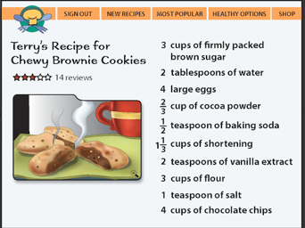

She wants to bake only 5/8 of the number of cookies the recipe will make. Rewrite her recipe so that it will make 5/8 as many chewy brownie cookies.

_____________ brown sugar
_____________ water
_____________ eggs
_____________ cocoa powder
_____________ baking soda
_____________ shortening
_____________ vanilla extract
_____________ flour
_____________ salt
_____________ chocolate chips

