Name: __________________________________________________________________ Class: _______________
Percent Increase/Percent Decrease
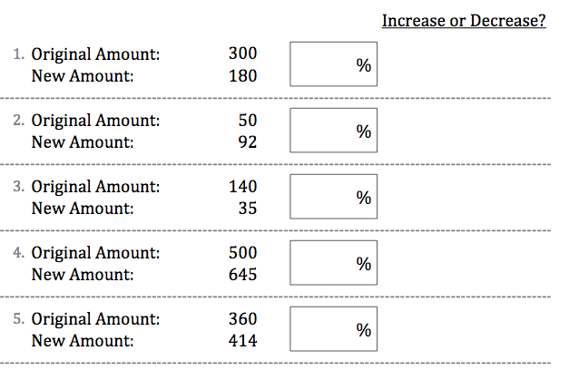

6. Last year only 75 people attended the annual holiday choir concert. This year, people were allowed to bring guests, so attendance increased by 36%. How many people attended the concert this year?

Answer: _____________________________

7. Yesterday morning I had $40 in my wallet. By the end of the day, this amount had decreased by 5%. How much money did I have in my wallet by the end of the day?

Answer: _____________________________

