Name: _______________________________________________________ Class: ____________

1. 0.3 x 14 2. 1.2 x 3.54 3. 1.04 x 0.6

4. 23.2 x 0.45 5. 0.54 x 1.2 6. 4.20 x 5.6

7. Brian plans to buy new flooring for his office. His office floor is a rectangle that is 7.9 meters by 6.2 meters.

- How many square meters of floor space does his office have?

- Suppose flooring costs $5.90 per square meter. How much will the new flooring for Brian’s office cost?

Name: _______________________________________________________ Class: ____________

Identify the errors in each calculation and find the correct product.
1.
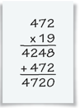________________________________________________________________
2.
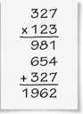_________________________________________________________________
3.
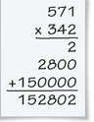________________________________________________________________
4.
