Name: ________________________________________________________________ Class: _________________

Integers Review

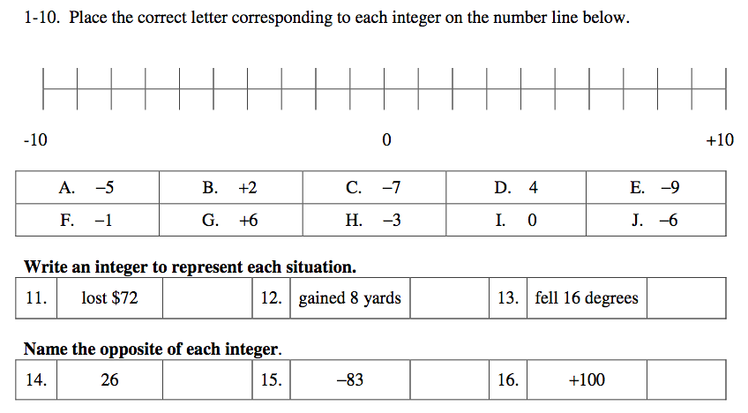

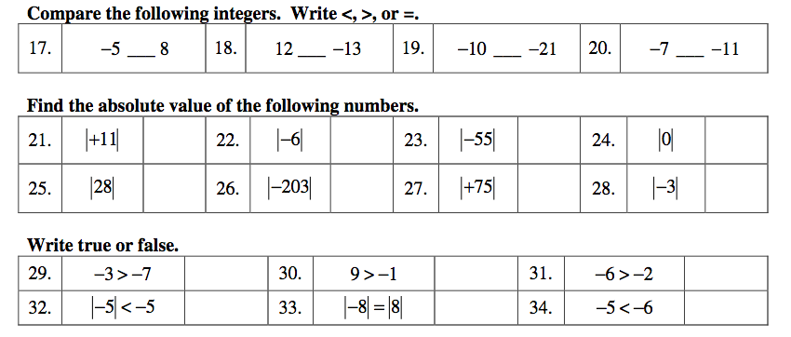

Macintosh HD:Users:admin:Desktop:Screen Shot 2016-10-20 at 9.25.19 AM.png

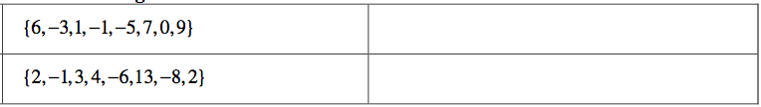

Macintosh HD:Users:admin:Desktop:Screen Shot 2016-10-20 at 9.25.28 AM.png

