Name: _______________________________________________________________ Class: __________________
Comparing Fractions
Directions: Compare each pair of fractions using < , > , or =. Show all work in the table below. An example for how work should be set up has been done for you.
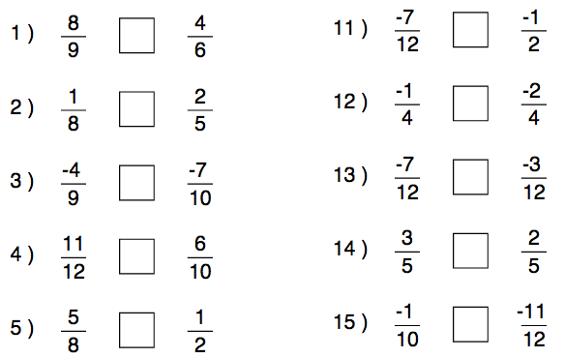
1)  8/9 x 4/4 = 32/36  4/6 x 6/6 = 24/36  32/36 > 24/36, so 8/9 > 4/6 | 11)
2) | 12)
3) | 13)
4) | 14)
5) | 15)
Name: _______________________________________________________________ Class: __________________
Comparing Fractions
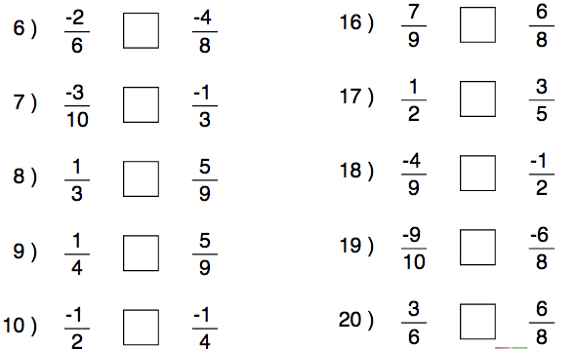

6) | 16)
7) | 17)
8) | 18)
9) | 19)
10) | 20)

