MCj02860060000[1]Name: ____________________________________________ Class: ______________

Points and Percentages: Combining Basketball Statistics and Mathematics

Use the following information to answer questions 1 – 8.

**G** Games Played **3PM** Three-point Shots Made

**FGM** Field Goals Made **3PA** Three-point Shots Attempted

**FGA** Field Goal Attempts **3P%** Three-point Shot Percentage

**FG%** Field Goal Percentage **PTS** Total Points Scored

**FTM** Free Throws Made **PPG** Average Points per Game

**FTA** Free Throws Attempted

**FT%** Free Throw Percentage

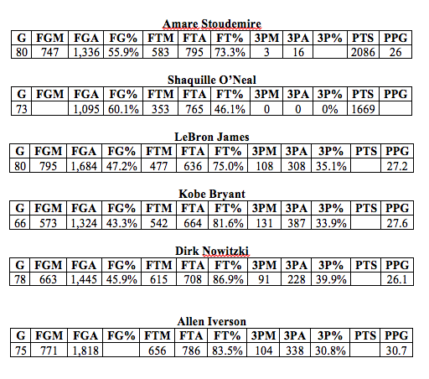

MCj02861440000[1]1. The fourth column in each table contains the field goal percentage for each player rounded to the nearest tenth. The field goal percentage is the percent of field goals attempted that are successfully made. Confirm that the field goal percentage for Kobe Bryant is correct. Show your work.

2. Notice that the field goal percentage for Allen Iverson is missing. Use what you know about percents to find the field goal percentage for Allen Iverson. Show all of your work and round your percentage to the nearest tenth.

3. The number of field goals made is missing for Shaquille O’Neal. However, the field goal percentage and attempts made are given. Find the number of field goals made by using the field goal percentage and the number of field goal attempts. Clearly show all of your work and explain your method.

MCj03630240000[1]

4. Field goals are worth 2 points, 3-point shots are worth 3 points, and free throws are worth 1 point. Given this information, fill in the total points scored for Lebron James, Kobe Bryant, Dirk Nowitzki, and Allen Iverson.

5. What is Shaquille’s Average Points per Game rounded to the nearest tenth? (PPG)

6. If a player has t total points, has played g games and has scored p points per game, write an expression that relates t, g, and p. Explain your reasoning.

Learning Target: I can recognize percent as a part to whole relationship

Students will…

- Work individually to convert decimals to percents.

- Work individually to convert fractions to percents.

- Work individually to set up and solve proportion to find percents.

- Work in groups to decide which basketball player is best based on number of shots made out of total

- show all work

- justify their solutions using mathematical vocabulary in explanations

- Complete fraction, decimal, percent reference table

Students will use data involving basketball players in order to analyze and interpret statistics. Students will convert between fractions, decimal, and percents to get a better understanding of and compare each player’s data. Students will explain how these values may be misleading when they are not represented by percetages.