Name: ____________________________________________________ Class: _______________

The Casals Family planted a big garden with flowers.
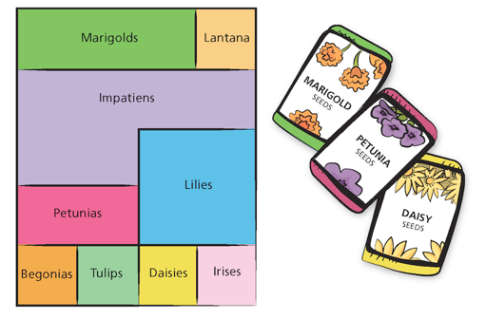

- About what fraction of the garden is planted with each type of flower?

Marigolds _________ Lantana __________ Impatiens __________
Petunias _________ Lilies __________ Begonias __________
Tulips _________ Daisies __________ Irises __________

- How much more of the garden is planted with lilies than daisies?

- The Casals replace the daisies and irises with lilies. What fraction of the garden is planted with lilies? Write this as a number sentence.

- In the following sentence, the name of each type of flower represents the fraction of the garden in which the flower is planted.

Marigolds – Begonias = Petunias + Tulips

Use fractions to explain whether the sentence is correct or incorrect.

____________________________________________________________________________________________________________________________________________________________________________________________________________________________________________________________________________________________________________________________

Determine which sum or difference is greater. Show your work.
5. 2/3 + 5/6 OR 3/4 + 4/5 6. 7/6 – 2/3 OR 3/5 – 5/10

